Assignment 7.5

Write a map only job for the word count program and set the output format as sequence file

Driver class

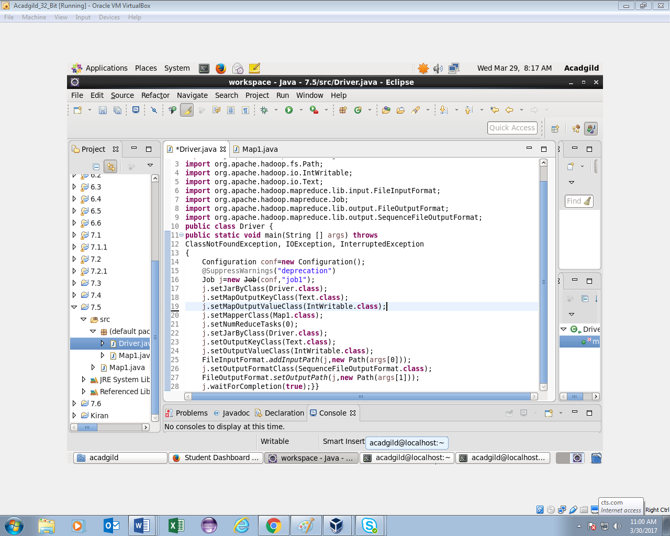

Mapper class

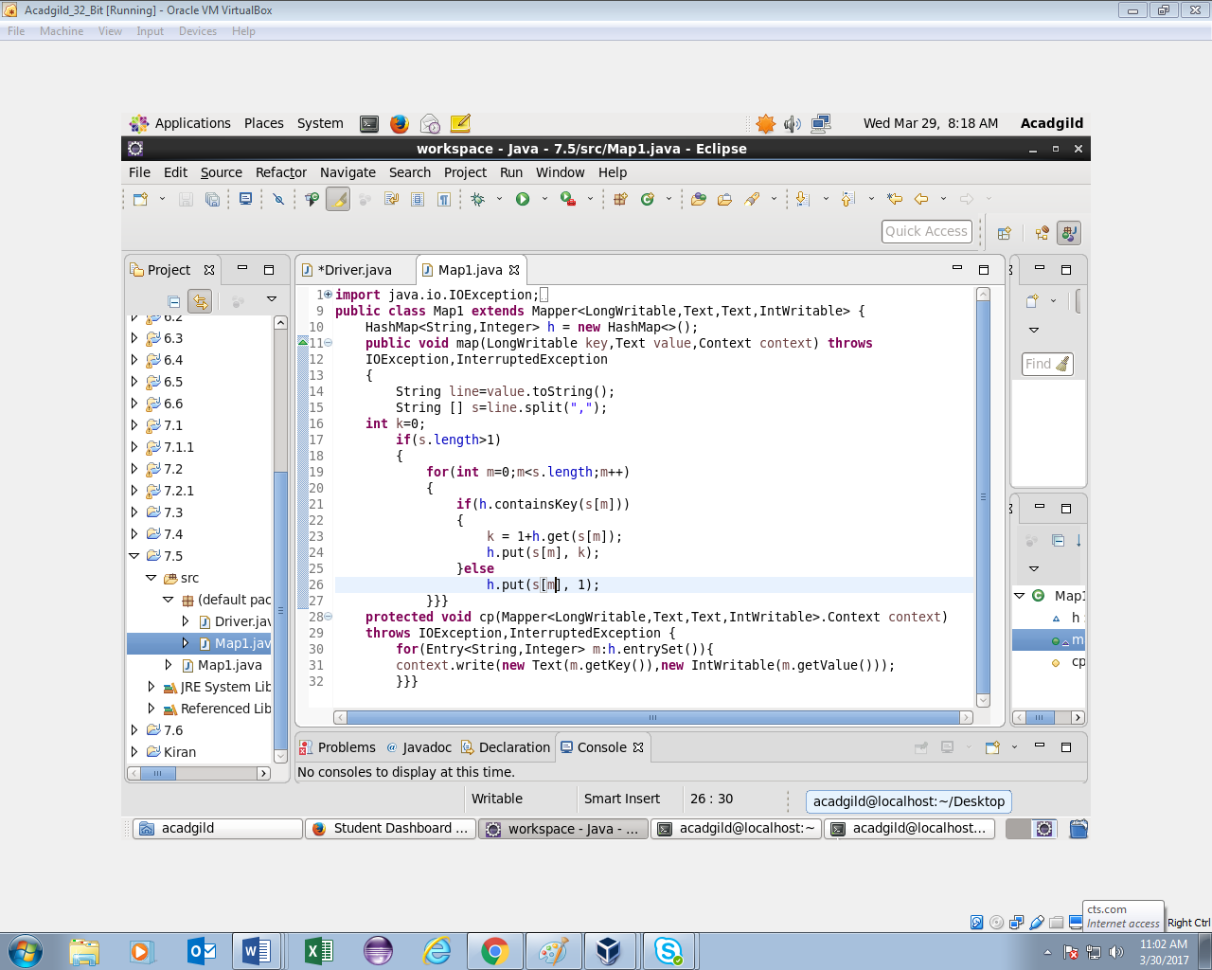

Running jar and output

